* **Credit Card: -**
* Click on Credit Card

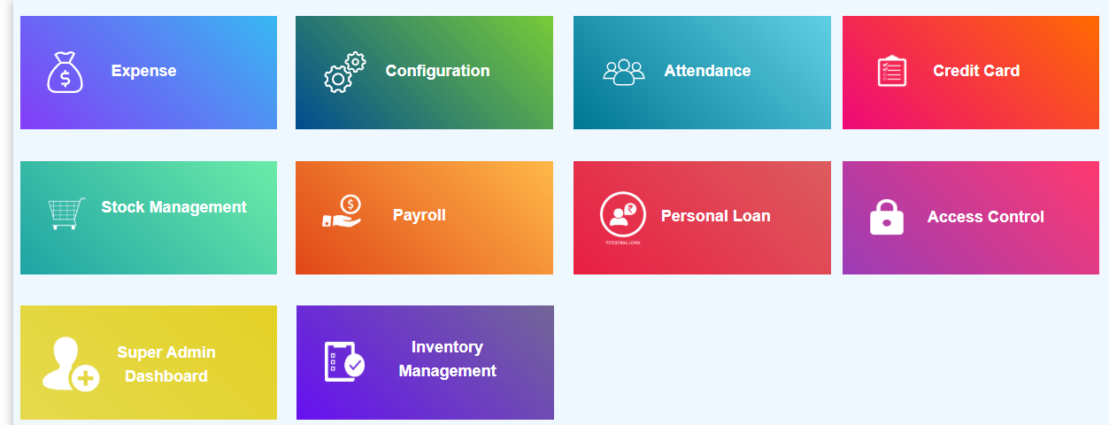

**a.Lead Sheet: -**

* Before filling the lead sheet form, add user with designation pick up executive and TME in configuration module.
* After that fill the lead sheet form with that pick up executive and TME names.

Note: CSA Name = TME Name

* Click on add lead button.
* Select date.
* Select time HH: MM.
* Select pick up executive name.
* Select CSA Name.

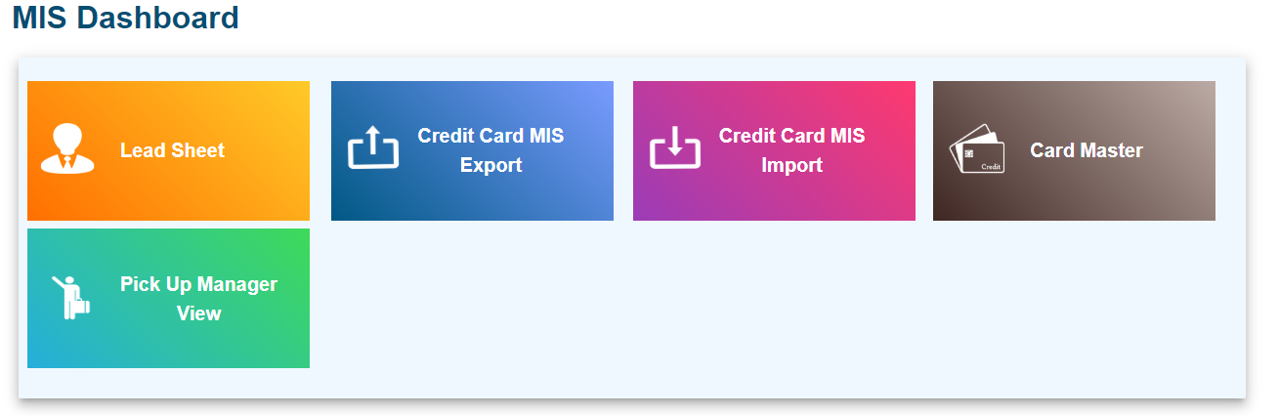

* Click on Lead Sheet
* Lead sheet contain lead master
* Lead master contains all leads created by particular user
* Super admin is able to see lead generated by all employees
* Product head/ Unit manager/ Team manager is able to see lead generated by own and lead generated by their team members also.
* Particular employee is able to see the lead generated by own not others

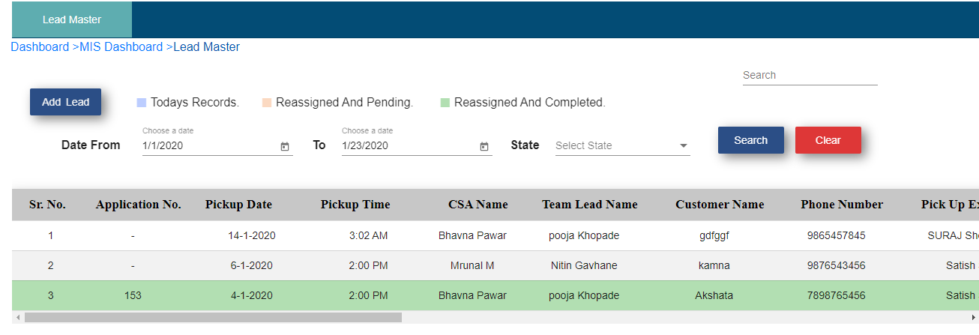

* Click on Add Lead
* Application number field will disable. Once pickup executive collects all documents to that particular user through the app then application number will be auto generated.

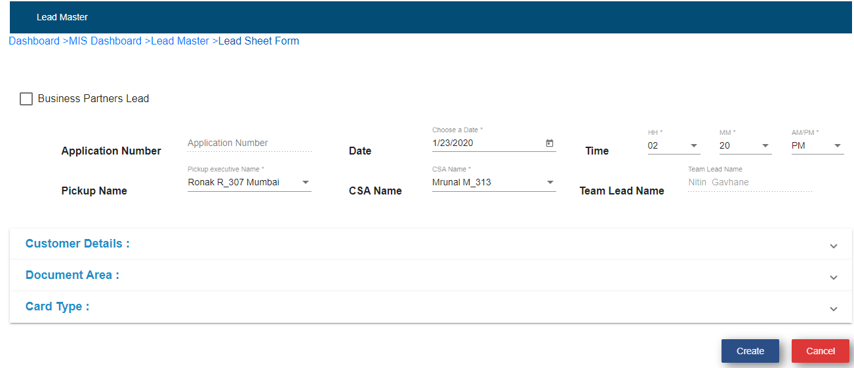

* Choose Date
* Choose Time
* Select Pick Up Executive
* Select CSA name
* Click on Customer Details

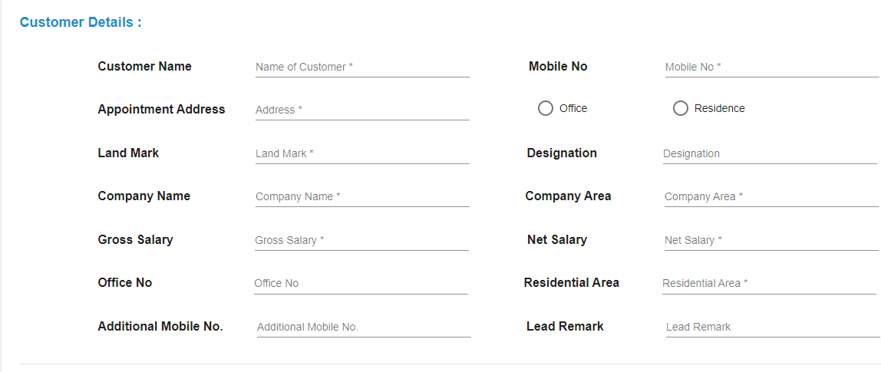

* Fill up all the details
* Click on document area

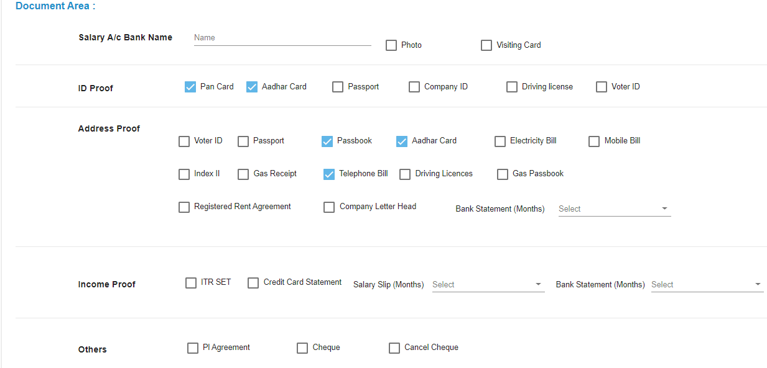

* Select documents
* Click on card type

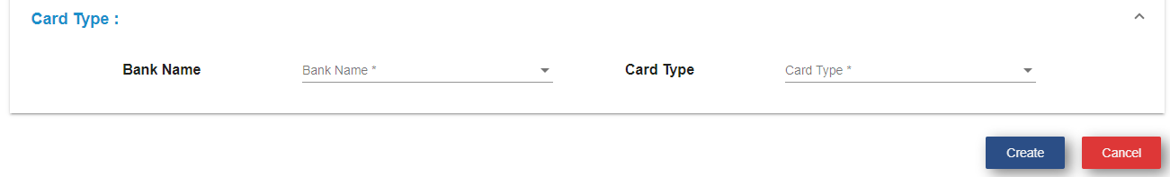

* Select bank name
* Select card Type
* Click on Create
* Click on Ok
* After click on create button, customer details display in the app to that particular pick up executive which TME selected while filling this lead sheet form.

**b)  Credit Card MIS Export**

* Click on credit card MIS export sub module.



* **Master Table**

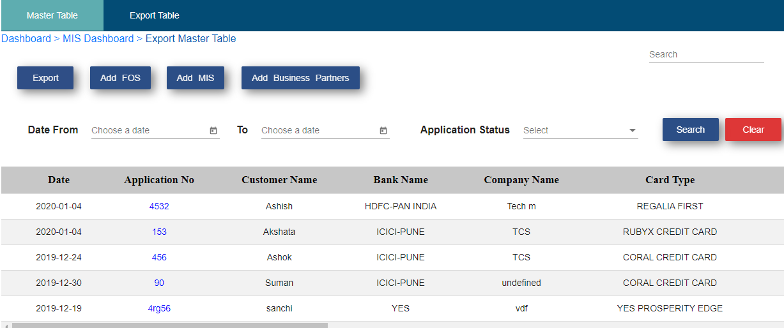

* FOS freelancer can add lead by clicking on Add FOS button
* Business partner can add lead by clicking on Add FOS button
* MIS executive can add lead by clicking on Add Business Partners
* Click on respective user on respective button
* Fill up the form
* Click on submit
* If user wants to edit the form then click on edit and do changes and click on update.
* If application status is Rework then operation field reassign icon is available, click on that icon Select **New Pickup Executive,** location, date and time

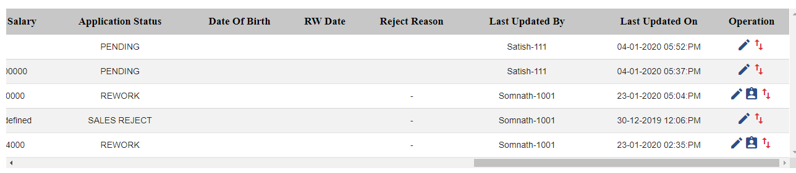

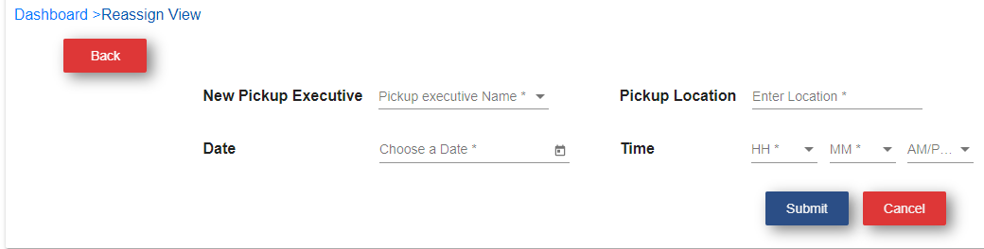

* Click on submit
* **Export Table:**

All Leads which are having status STB, these leads are display in Export table

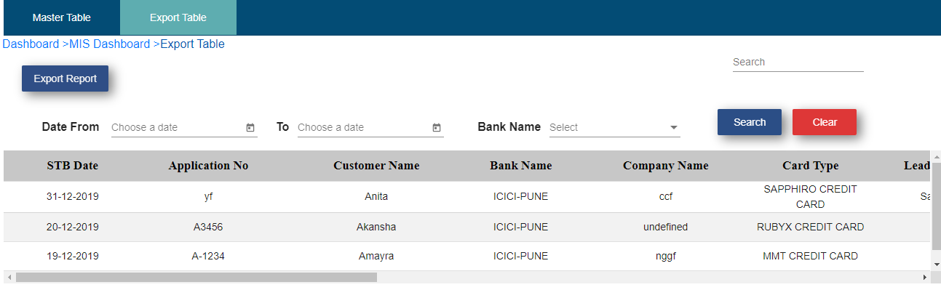

**Export report:** To download export tables records follow below process:

* Click on export report
* Click on ok

MIS Bank STB Report get downloaded as shown below

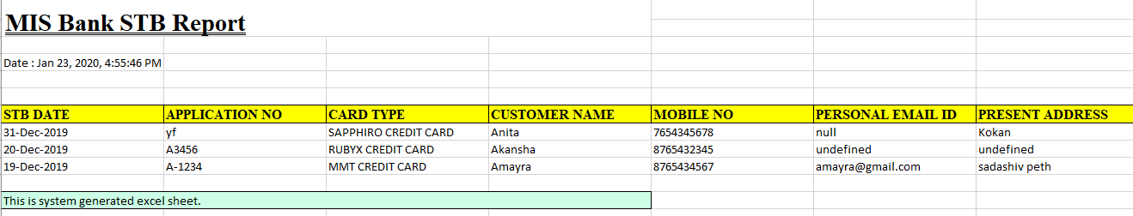

**C)Credit Card MIS Import:**

* Click on Credit Card MIS Import



Note: 1. While uploading the excel sheet, file format should be same as bank sent to company.

  2. Upload file format should be as follows:

|  |  |  |  |  |  |  |
| --- | --- | --- | --- | --- | --- | --- |
| APPLICATION NO | CUSTOMER NAME | Decision Date | Application Status | Rejection Remark | Decline Code | LOGO(CARD TYPE) |

  3. DIP upload file format should be as follows:

|  |  |  |  |
| --- | --- | --- | --- |
| APPLICATION NO | CUSTOMER NAME | Decision Date | DIP Status |

        4. Decision date in the file must be in “YYYY/MM/DD” format.

  5. While uploading booking and DIP ok sheet, file extension must be in .xlsx .

6. Excel sheet converts application number like 00123 to 123 there for it mismatches the                                                        application number and particular record go to the error log. So application number should not start from ‘0’.

5. If application number is greater than 10 then excel sheet will convert it into scientific notation as 1.2408E+12 and which will not matching with application number. So particular record will go to error log. So user need to convert the excel sheet cell into proper format.

**1. Upload**

* Click on upload tab.

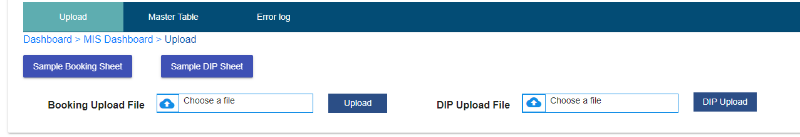

Fig. Import Upload and DIP Upload

* Choose a file.
* Click on upload button.
* Record will show in master table.
* Click on DIP.
* Choose a file.
* Click on DIP upload button.
* Record will show in master table

**2. Master Table**

* After uploading and DIP uploading the file, records will show in master table.
* Click on date from and date to.
* Select bank name.
* Select status.
* Click on search.
* After click on search button, particular record related to that search will display.

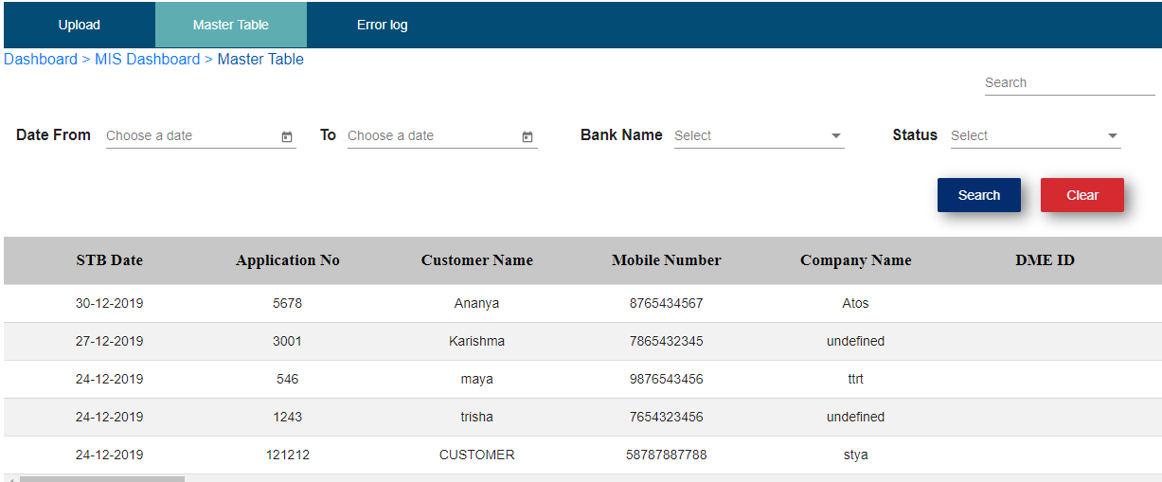

**3. Error Log**

* Click on error log.
* If application number mismatches in excel sheet then it will go to error log.
* Select date from and date to.
* Click on search button.
* After click on search button particular record will display.

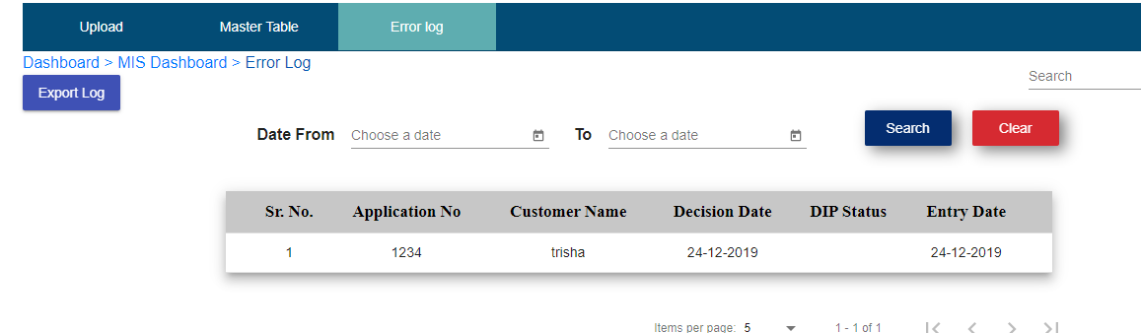

**Export Log:**

* Click on Export log
* Click on export
* Click on ok
* Error log sheet get downloaded as shown below

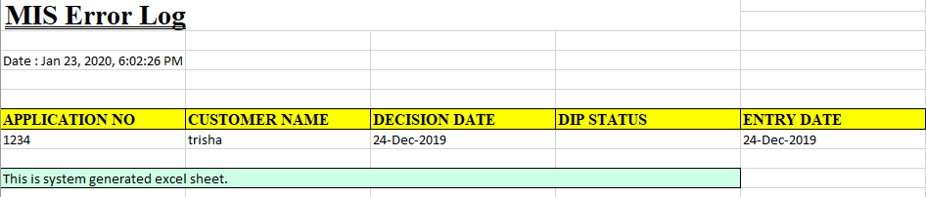

**d)Card Master:**

* Click on Card Master



* Click on Add

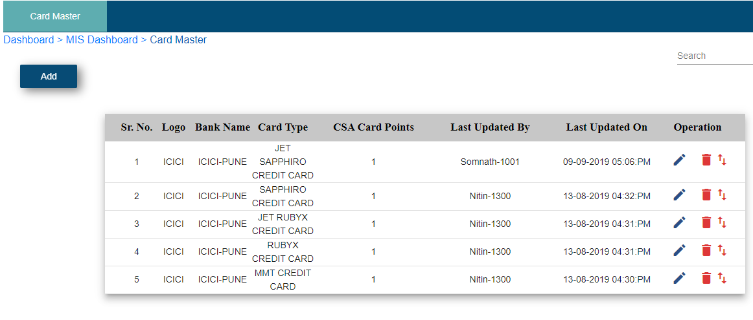

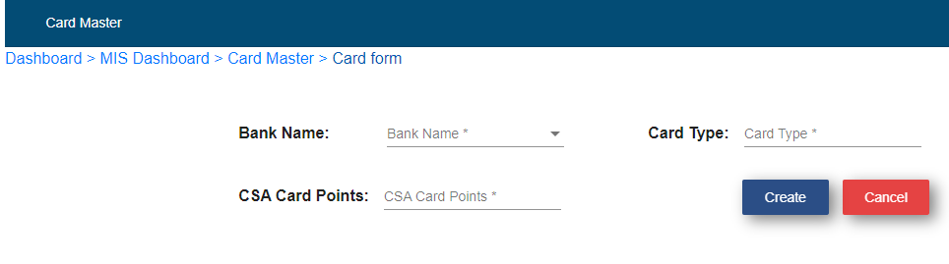

* Select Bank name
* Select Card Type
* Enter CSA card points
* Click on create